**(Cover Page Image)**

**DSC5101 Group Assignment 2**

A Relook at “Risk Targeting and Policy Illusions – Evidence from the Announcement of the Volcker Rule”



**November 3, 2019**

Group Members

Utkarsh Chaturvedi ( )

Dasol Kim ( )

Shengnan Sang ( )

Nikhil Thomas ( )

Table of Contents

**Executive Summary** 3

**Understanding Trading Asset Ratio** 3

**Model Implementation & Analysis** 4

**Baseline Model** 4

**Model Equations** 4

**Model results & understanding** 5

**Robustness Tests** 5

**Summary & Recommendations** 6

**Appendix** 8

Figures: 8

Tables: 12

References: 14

# 

# **Executive Summary**

Enacted into law on July 21, 2010, the Dodd-Frank Wall Street Reform and Consumer Protection Act (“Dodd-Frank Act/DFA”), also referred to as the Volcker Rule, prohibits any banking institution from a) engaging in short-term proprietary trading of securities, derivatives, commodity futures and options; b) owning and sponsoring hedge funds or private equity funds. In wake of the 2008 global financial crisis, the Volcker Rule’s primary goal was to enhance banks’ safety and soundness through minimizing exposure to non-banking capital market risks. Exemptions were provided for specific activities including a) underwriting, market making-related, risk-mitigating hedging, trading of government obligations and other activities that improve the U.S. financial stability; b) investing in general corporate purpose companies such as foreign public funds, wholly-owned subsidiaries, joint ventures, acquisition and securitization-related vehicles. Note that an effective implementation of the regulation remained to be seen until 2016 due to the lag in agreement among regulatory agencies as well as the provision of a two to five-year conformance period.

This report will focus on the construction of linear regression model that incorporates an interaction variable, controlling covariates, and fixed time effects. Specifically, results produced from the above model demonstrate several key findings.

1. First, after the announcement of the Volcker Rule, banks decreased their trading assets
2. Second, banks that had significant trading asset ratios before DFA responded to the regulation the most, while this effect was not pronounced for those with low pre-DFA trading asset ratios
3. Finally, robustness tests suggest that the findings are beneficial to both the banking entities and regulatory bodies

# **Understanding Trading Asset Ratio**

Trading Asset ratios is used as a measurement metric to understand the effect that DFA (Volcker Rule) had on banking business. The Volcker Rule limited certain banking activities such as proprietary trading that were termed as “risky investments”. The Trading Asset Ratio is defined as the ratio of Trading Assets to Total Assets of the BHC – hence a higher Trading Asset Ratio becomes unfavorable to the current banking regulations. The following represents how there were certain banks that did have very high trading asset ratios (leveraged towards very risky investments) but the majority had negligible Trading Asset Ratios.

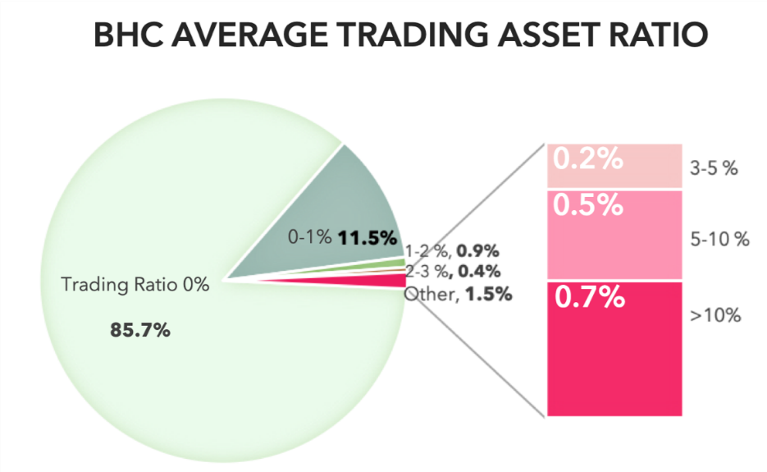

Note that 41,442 missing observations have been omitted for simplicity.

# **Model Implementation & Analysis**

**Assumption 1:** Bank holding companies with traditionally relatively large trading books pre-DFA will have the most impact and display substantial reaction to the Volcker Rule.

**Hypothesis 1:** *The affected banks started to reduce their trading asset ratio after the announcement of the Volcker Rule (Jussi Keppo, Josef Korte, 2018).*

Initial preliminary models were run with regressing Trading Asset Ratios against the DFA Flag (with and without control variables) however these led to insignificant results and showed that there was no effect that DFA had on Trading Asset Ratios.

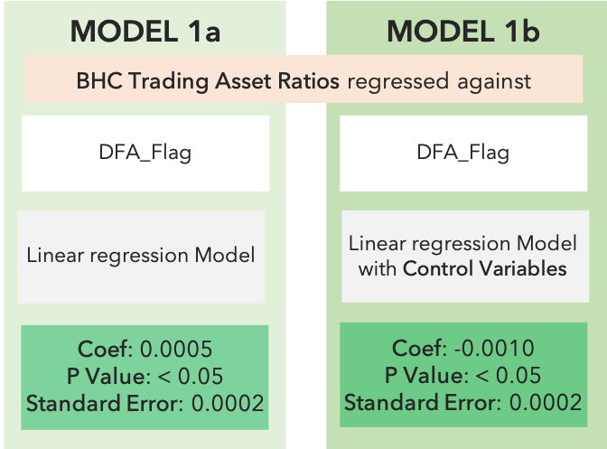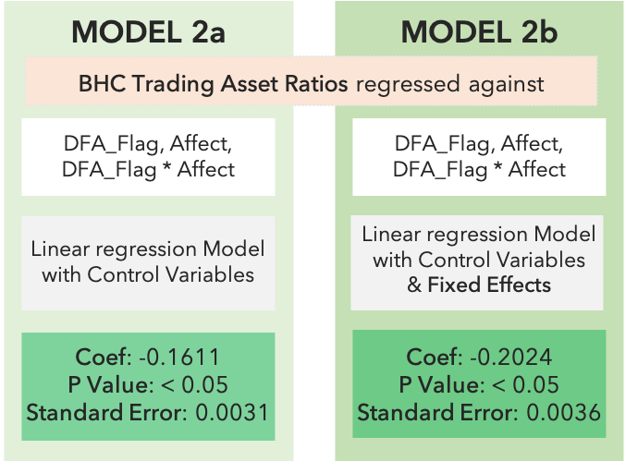

# **Baseline Model**

To better understand the effect of the Volcker Rule, we define a more extensive model that is truly able to gauge the impact that Volcker Rule had on trading asset ratios post the implementation of the new regulations.

# **Model Equations**

To truly understand the effect that Volcker Rule has had on the trading ratios of BHCs, we have used a simple regression model with the following equation –

* ***TradingAssetRatio***is the BHC’s trading asset ratio in each quarter from 2004 to 2015, which is modelled in this analysis
* A variable has been engineeredasbinary variable, to indicate the pre-post time of DFA coming into effect
* Variable is has been calculated as the average trading asset ratio from third quarter 2004 to second quarter 2009
* Interaction variable was created between these 2 variables. **Control Variables** and **Fixed Effects** were added to make the model robust.
* For the list of control variables used, refer Table 1.1 in the Appendix

# **Model results & understanding**

With the addition of the *Affect* and the Interaction variable of DFA implementation flag and the pre-DFA Trading ratios we now see that there is a significant effect that was brought in with the implementation of DFA.

#### Measuring magnitude & impact of DFA against pre-DFA trading ratios

**Testing for non-linear trends:**

We added squared effects to our *Affect* variable to check if any non-linear trends are present or can be captured. While the effects of this iteration(s) corroborate our results above, we find no evidence that a non-linear trend of reduction in trading ratio exists.

#### Impact on banks

Having established that Volcker Rule have had an effect on the trading ratios of banks, we look into which banks have been affected the most. Observing the coefficient value of interaction variable *(Affect*pre_DFA_flag)*, we observe it to be significant & negative.

The coefficient is particularly interesting in the way it’s interacting with *Affect*. An interpretation of this interaction coefficient could be that as ‘*Affect’* value increases (i.e. for banks having higher pre-DFA trading ratio), the magnitude of drop in trading ratios is higher. E.g. for banks with 0.1% average pre-DFA trading ratio, the magnitude of effect of DFA would be *(-0.1%*16.1%),* but for banks with 10% pre-DFA trading ratio, the magnitude is *(-10%*16.1%).*

The interaction variable with fixed effects tries to improve upon this even further. Since BHC’s have been controlled along with period, the *Affect* variable is now acting as a counter-factual for treatment group during the post-DFA period. So, the interaction effect is now measuring the percentage drop in trading ratio observed, after being controlled for each bank.

Hence, we conclude that, if the pre-trading ratio of banks are higher *(‘Affect’),* the effect of DFA is more pronounced. **Classification for impact on banks (2-3%, 3-5%, 5-10%, 10+):**

# **Robustness Tests**

In order to ensure that the preceding results are indeed coherent and robust, control variables and fixed effects were incorporated into all models. Furthermore, testing of robustness was performed, which included difference-in-differences and propensity score matching techniques.

1. After running a difference-in-differences model with only bank holding companies that had pre-DFA trading asset ratios greater than or equal to 3% as the treatment group, the model still yielded significant coefficients of -0.023376.
2. Propensity score matching was used for both the treatment and control groups based on the control variables, which ultimately resulted in coefficients of approximately -0.028878.

The propensity matching exercise leads to better matched samples in the test and control which further reinforces the results and prevents any reason of their being bias in the data – since the propensity matching was done with the first quarter of the data for all BHCs based on a vector created by the control variables.

The two robustness tests above indicate the effectiveness of the Volcker Rule based on banks’ trading asset ratio. However, it should be noted that the model assumes all else to be held constant. This is not necessarily always the case since banks may be driven to modify their business models after the 2008 financial crisis. Consequently, the following additional tests are carried out:

1. Account for banks’ asset trading ratios pre-DFA
2. Take out bank holding companies that had 0 trading asset ratio pre-DFA

Overall, it is confirmed that the final regression model produces strong and robust results: banks decreased their trading asset ratios after the announcement of the Volcker Rule.

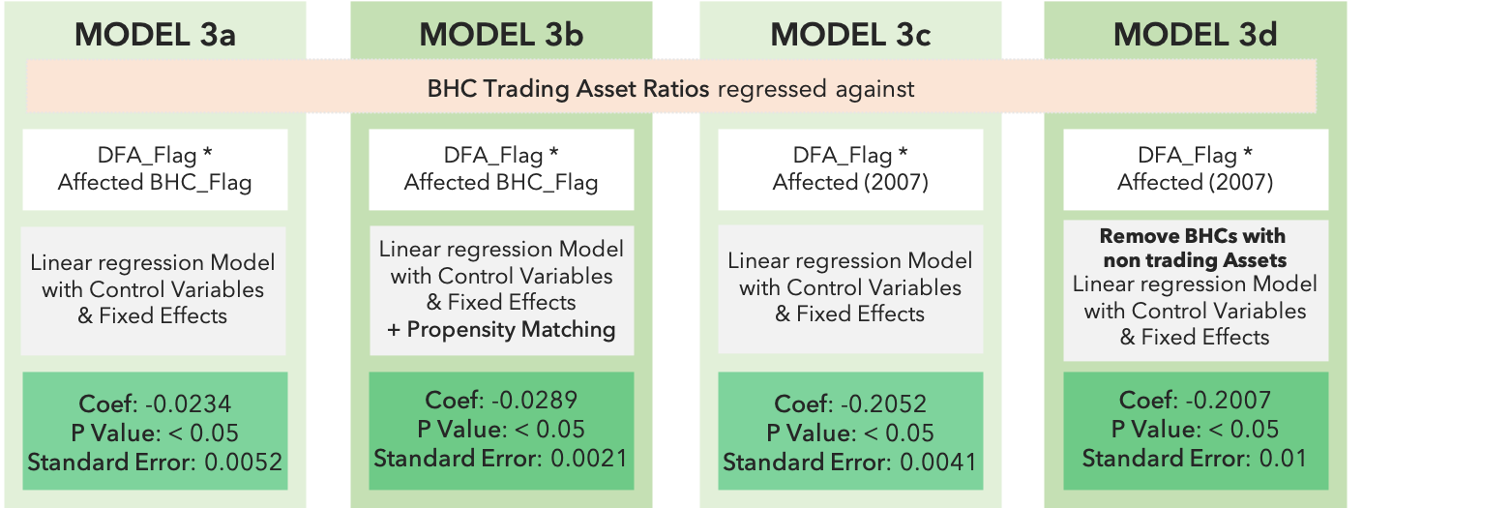

# **Summary & Recommendations**

Overall, the results indicate that the Volcker Rule effectively steered a decrease in banks’ trading asset ratios, of which banking entities with predominant trading activities prior to the announcement demonstrated stronger reactions to the regulation. Note that the majority of bank holding companies had close to zero or insignificant trading asset ratios preceding the Dodd-Frank Act. This further warrant robustness testing in order to evaluate the strength of statistical model in the treatment and control groups.

These findings are meaningful for both the financial institutions and its regulatory authorities. Authorities such as the Basel Committee on Banking Supervision and the International Association of Insurance Supervisors concurred and delineated a list of global systematically important banks “G-SIBs”. Historically, such banks maintain considerable equity trading portfolios, and in accordance to the model implications, responded the most after the announcement of the Volcker Rule. Hence, separate regulatory compliance requirements should be imposed on the peer groups. Concurrently, smaller financial institutions will be categorized into another peer group based on factors including total amount of assets, cross-jurisdictional network and reach, interconnectedness, infrastructure, and complexity and diversification of transaction activities. Specifically, risk-based “CAMELS” monitoring system is an ideal barometer for assessing bank entities’ overall well-being. The scoring test is comprised of “Capital Adequacy”, “Asset Quality”, “Management”, “Earnings”, “Liquidity”, and “Sensitivity to Market Risk”. Among all factors within the framework, management of internal market and liquidity risks is key to improving the bank entities’ resiliency. It should be emphasized that smaller-sized banks be subject to more flexibility in terms of business lines and risk levels.

In addition to suitable monitoring frameworks upheld by regulatory agencies, the bank entities themselves should aim to enhance current capital allocation optimization models and undertake self-regulation to a certain degree. In fact, the analysis indicates that while affected bank holding companies reduced trading asset ratios after announcement of the Volcker Rule, the asset return volatility has significantly increased, and thus, banks were able to maintain their target risk ratios.

## **Appendix**

### Figures:

**1.1 Model 1a:**

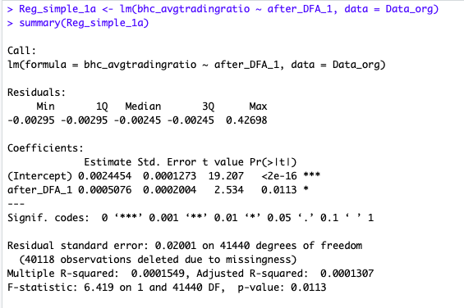

**1.2 Model 1b:**

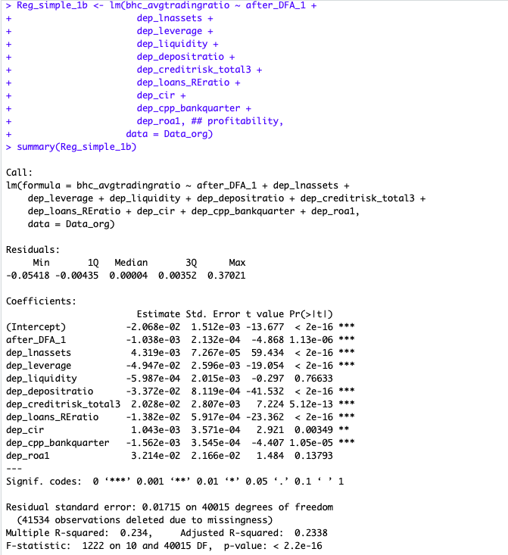

* 1. **Model 2a:**

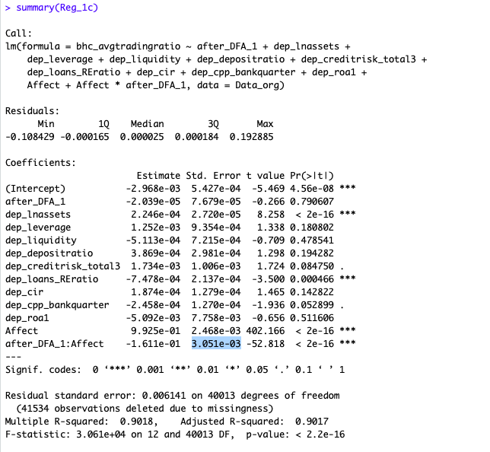

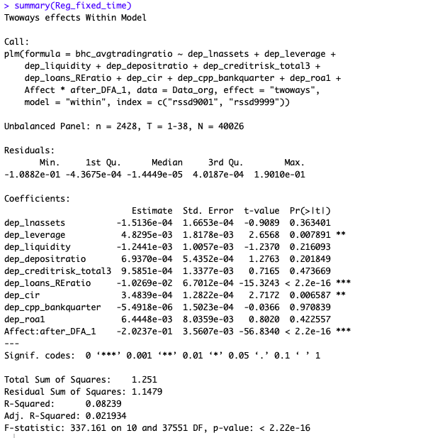**2.2 Model 2b:**

**1.3 Model 1c:**

**3.1 Model 3a:**

## 

**3.2 Model 3b:**

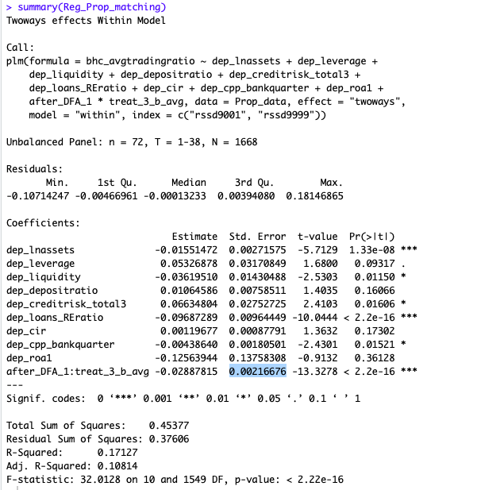

**3.3 Model 3c:**

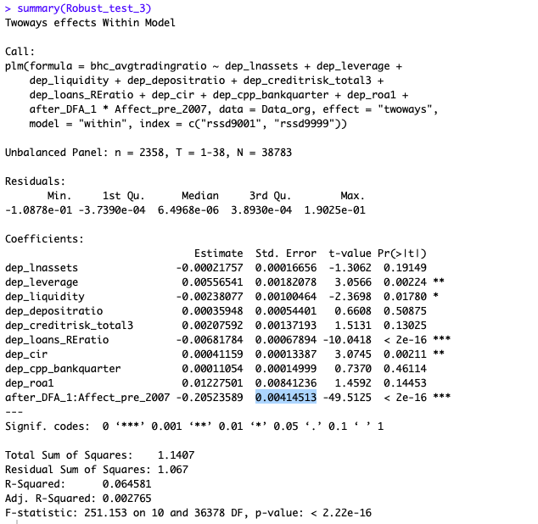

**3.4 Model 3d:**

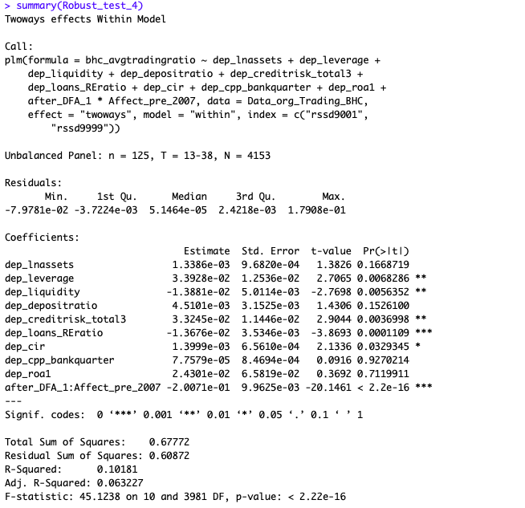

### Tables:

**1.1 List of control variables:**

|  |  |
| --- | --- |
| Total assets | Natural logarithm of total assets |
| Leverage ratio | Average equity divided by average total assets |
| Profitability | Net income divided by average total assets |
| Liquidity ratio | Cash and balances at other depository institutions divided by total assets |
| Deposit ratio | Average deposits divided by average total assets |
| Cost-income ratio | Operating expenses divided by total income |
| Nonperforming loan ratio | Past due and nonaccrual loans divided by total loans |
| Real estate loan ratio | Loans secured by real estate divided by total loans |
| CPP recipient indicator | Capital Purchase Program indicator binary variable |

**1.2 Propensity Matching:**

Summary of balance for all data:

Means Treated Means Control SD Control Mean Diff eQQ Med eQQ Mean eQQ Max

distance 0.5447 0.0105 0.0360 0.5343 0.6226 0.5126 0.9314

dep_lnassets 17.7727 13.1233 1.2477 4.6495 5.2155 4.5758 6.7666

dep_leverage 0.0825 0.0937 0.0345 -0.0113 0.0075 0.0232 0.2536

dep_liquidity 0.0477 0.0397 0.0283 0.0081 0.0030 0.0245 0.3021

dep_depositratio 0.3462 0.6672 0.1051 -0.3211 0.3220 0.3040 0.4670

dep_creditrisk_total3 0.0208 0.0177 0.0168 0.0031 0.0035 0.0128 0.1617

dep_loans_REratio 0.5095 0.6992 0.1489 -0.1896 0.1977 0.1764 0.2710

dep_cir 0.4704 0.5058 0.1513 -0.0354 0.0320 0.1727 2.4278

dep_cpp_bankquarter 0.0000 0.0000 0.0000 0.0000 0.0000 0.0000 0.0000

dep_roa1 0.0031 0.0029 0.0030 0.0002 0.0003 0.0051 0.0556

Summary of balance for matched data:

Means Treated Means Control SD Control Mean Diff eQQ Med eQQ Mean eQQ Max

distance 0.5447 0.2769 0.1857 0.2678 0.5708 0.4535 0.8599

dep_lnassets 17.7727 16.9081 1.9861 0.8646 3.2135 2.7773 3.9687

dep_leverage 0.0825 0.0890 0.0194 -0.0065 0.0032 0.0082 0.0832

dep_liquidity 0.0477 0.0606 0.0549 -0.0129 0.0065 0.0126 0.0657

dep_depositratio 0.3462 0.4337 0.1666 -0.0875 0.2216 0.2071 0.3033

dep_creditrisk_total3 0.0208 0.0121 0.0094 0.0087 0.0061 0.0075 0.0149

dep_loans_REratio 0.5095 0.4923 0.1673 0.0172 0.0829 0.0873 0.1699

dep_cir 0.4704 0.5493 0.1771 -0.0789 0.0180 0.0316 0.2426

dep_cpp_bankquarter 0.0000 0.0000 0.0000 0.0000 0.0000 0.0000 0.0000

dep_roa1 0.0031 0.0027 0.0025 0.0004 0.0004 0.0008 0.0063

Percent Balance Improvement:

Mean Diff. eQQ Med eQQ Mean eQQ Max

distance 49.8793 8.3248 11.5374 7.6856

dep_lnassets 81.4041 38.3854 39.3052 41.3492

dep_leverage 41.9111 57.4377 64.6527 67.1846

dep_liquidity -59.5066 -116.8199 48.6839 78.2683

dep_depositratio 72.7386 31.1845 31.8803 35.0403

dep_creditrisk_total3 -179.5325 -74.5364 41.3991 90.8106

dep_loans_REratio 90.9082 58.0502 50.5397 37.3072

dep_cir -122.8331 43.6474 81.7202 90.0068

dep_cpp_bankquarter 0.0000 0.0000 0.0000 0.0000

dep_roa1 -182.5071 -24.7034 84.0083 88.7502

Sample sizes:

Control Treated

All 783 18

Matched 22 18

Unmatched 761 0

Discarded 0 0

**1.3 Non-linearity test #1(using FE):**

Call:

plm(formula = bhc_avgtradingratio ~ after_DFA_1 + dep_lnassets +

dep_leverage + dep_liquidity + dep_depositratio + dep_creditrisk_total3 +

dep_loans_REratio + dep_cir + dep_cpp_bankquarter + dep_roa1 +

Affect + Affect_squared + Affect * after_DFA_1 + Affect_squared *

after_DFA_1, data = Data_org, effect = "twoways", model = "within",

index = c("rssd9001", "rssd9999"))

Unbalanced Panel: n = 2428, T = 1-38, N = 40026

Residuals:

Min. 1st Qu. Median 3rd Qu. Max.

-1.0883e-01 -4.5857e-04 -2.2389e-05 4.0625e-04 1.9008e-01

Coefficients:

Estimate Std. Error t-value Pr(>|t|)

dep_lnassets -1.6122e-04 1.6619e-04 -0.9701 0.332005

dep_leverage 5.7391e-03 1.8154e-03 3.1613 0.001572 **

dep_liquidity -1.1384e-03 1.0037e-03 -1.1342 0.256720

dep_depositratio 8.9877e-04 5.4264e-04 1.6563 0.097670 .

dep_creditrisk_total3 1.1062e-03 1.3350e-03 0.8286 0.407333

dep_loans_REratio -1.0818e-02 6.7016e-04 -16.1420 < 2.2e-16 ***

dep_cir 3.7363e-04 1.2797e-04 2.9197 0.003505 **

dep_cpp_bankquarter 1.0902e-05 1.4993e-04 0.0727 0.942035

dep_roa1 7.6922e-03 8.0199e-03 0.9591 0.337495

after_DFA_1:Affect -3.0338e-01 8.8088e-03 -34.4404 < 2.2e-16 ***

after_DFA_1:Affect_squared 4.3512e-01 3.4721e-02 12.5317 < 2.2e-16 ***

---

Signif. codes: 0 ‘***’ 0.001 ‘**’ 0.01 ‘*’ 0.05 ‘.’ 0.1 ‘ ’ 1

Total Sum of Squares: 1.251

Residual Sum of Squares: 1.1431

R-Squared: 0.086212

Adj. R-Squared: 0.025982

F-statistic: 322.061 on 11 and 37550 DF, p-value: < 2.22e-16

**1.4 Non-linearity test #1(without FE):**

Call:

lm(formula = bhc_avgtradingratio ~ after_DFA_1 + dep_lnassets +

dep_leverage + dep_liquidity + dep_depositratio + dep_creditrisk_total3 +

dep_loans_REratio + dep_cir + dep_cpp_bankquarter + dep_roa1 +

Affect + Affect_squared + Affect * after_DFA_1 + Affect_squared *

after_DFA_1, data = Data_org)

Residuals:

Min 1Q Median 3Q Max

-0.107147 -0.000262 0.000003 0.000217 0.194160

Coefficients:

Estimate Std. Error t value Pr(>|t|)

(Intercept) -3.837e-03 5.434e-04 -7.061 1.68e-12 ***

after_DFA_1 1.257e-05 7.685e-05 0.164 0.8701

dep_lnassets 3.089e-04 2.770e-05 11.152 < 2e-16 ***

dep_leverage 1.608e-03 9.312e-04 1.727 0.0842 .

dep_liquidity 1.417e-04 7.190e-04 0.197 0.8438

dep_depositratio 1.000e-04 2.973e-04 0.336 0.7366

dep_creditrisk_total3 2.465e-03 1.002e-03 2.460 0.0139 *

dep_loans_REratio -9.974e-04 2.131e-04 -4.681 2.87e-06 ***

dep_cir 2.663e-04 1.274e-04 2.091 0.0366 *

dep_cpp_bankquarter -2.360e-04 1.264e-04 -1.866 0.0620 .

dep_roa1 -2.834e-03 7.723e-03 -0.367 0.7137

Affect 9.749e-01 6.031e-03 161.654 < 2e-16 ***

Affect_squared 6.078e-02 2.387e-02 2.546 0.0109 *

after_DFA_1:Affect -2.541e-01 8.105e-03 -31.348 < 2e-16 ***

after_DFA_1:Affect_squared 2.759e-01 2.894e-02 9.533 < 2e-16 ***

### References:

The Federal Deposit Insurance Corporation. *Deposit Insurance Assessments.* Retrieved October 25, 2019 from <https://www.fdic.gov/deposit/insurance/assessments/risk.html>

Federal Reserve Economic Data (FRED) by the Federal Reserve Bank of St. Louis. *The ABCs of CAMELS.* Retrieved October 25, 2019 from <https://www.stlouisfed.org/on-the-economy/2018/december/camels-ratings-liquidity>

The Federal Reserve Board of Governors. *Trading Activities at Systemically Important Banks, Part 3: What Drives Trading Performance?* Retrieved October 25, 2019 from <https://www.federalreserve.gov/econres/notes/feds-notes/trading-activities-at-systemically-important-banks-part-3-what-drives-trading-performance-20170710.html>